Chapter 6, Problem 31.

If v(0)=0, find v(t), i₁(t), and i₂(t) in the circuit in Fig. 6.63.

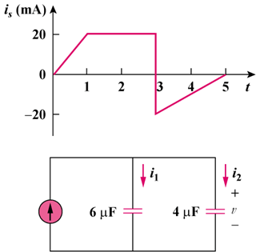
30
–30

Figure 6.63
For Prob. 6.31.

